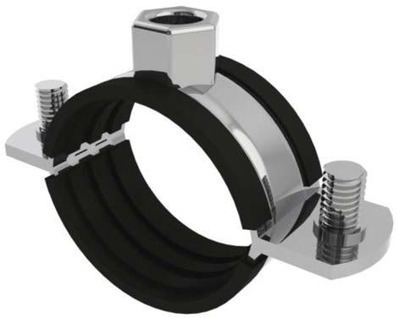

General Description
Fully 316 Stainless Steel Clips with EPDM Rubber Lining Key Features & Benefits
316 Stainless Steel
Durable EPDM Rubber Lining
M8/M10 Dual Boss.
Stainless Steel Screws.

Material Specification
Clip: 316 Stainless Steel
Screws: 316 Stainless Steel Rubber Liner: EPDM

Additional Information
- Truebore & Iso Stainless steel tubes.
- Small bore pressfit stainless steel tubes.
- Hygenic, Clean Rooms, Waste Water & Clean Water, Data Centres & Utilities.
- Outdoor & Saltwater Environments.

BSS Code | SIZE | RANGE  (фD) (mm) | STEEL SIZE(TxW) | SCREW SIZE | BOSS SIZE
 | 3/8" | 15-19 | 1.8x20 | M6x20 | M8/10
 | 1/2" | 20-25 | 1.8x20 | M6x20 | M8/10
 | 3/4" | 26-30 | 1.8x20 | M6x20 | M8/10
 | 1" | 32-36 | 1.8x20 | M6x20 | M8/10
 | 1-1/4" | 38-43 | 1.8x20 | M6x20 | M8/10
 | 1-1/2" | 47-51 | 1.8x20 | M6x20 | M8/10
 | 54mm | 53-58 | 1.8x20 | M6x20 | M8/10
 | 2" | 60-64 | 1.8x20 | M6x20 | M8/10
 | 70mm | 68-72 | 1.8x20 | M6x20 | M8/10
 | 83mm | 81-86 | 1.8x20 | M6x20 | M8/10
 | 3" | 87-92 | 1.8x20 | M6x20 | M8/10
 | 3-1/2 | 99-105 | 1.8x20 | M6x20 | M8/10
 | 4" | 113-118 | 1.8x20 | M6x20 | M8/10
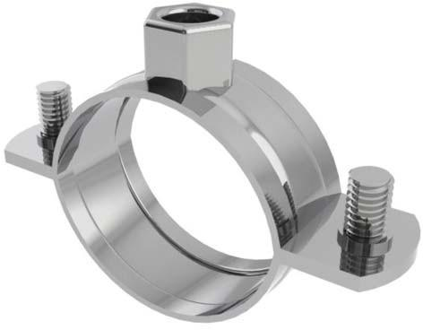

General Description
Fully 316 Stainless Steel Clips with unlinee Key Features & Benefits
316 Stainless Steel
M8/M10 Dual Boss.
Stainless Steel Screws.

Material Specification
Clip: 316 Stainless Steel
Screws: 316 Stainless Steel Rubber Liner: None

Additional Information
- Truebore & Iso Stainless steel tubes.
- Small bore pressfit stainless steel tubes.
- Hygenic, Clean Rooms, Waste Water & Clean Water, Data Centres & Utilities.
- Outdoor & Saltwater Environments.

BSS Code | SIZE | RANGE  (фD) (mm) | STEEL SIZE(TxW) | SCREW SIZE | BOSS SIZE
 | 3/8" | 15-19 | 1.8x20 | M6x20 | M8/10
 | 1/2" | 20-25 | 1.8x20 | M6x20 | M8/10
 | 3/4" | 26-30 | 1.8x20 | M6x20 | M8/10
 | 1" | 32-36 | 1.8x20 | M6x20 | M8/10
 | 1-1/4" | 38-43 | 1.8x20 | M6x20 | M8/10
 | 1-1/2" | 47-51 | 1.8x20 | M6x20 | M8/10
 | 54mm | 53-58 | 1.8x20 | M6x20 | M8/10
 | 2" | 60-64 | 1.8x20 | M6x20 | M8/10
 | 70mm | 68-72 | 1.8x20 | M6x20 | M8/10
 | 83mm | 81-86 | 1.8x20 | M6x20 | M8/10
 | 3" | 87-92 | 1.8x20 | M6x20 | M8/10
 | 3-1/2 | 99-105 | 1.8x20 | M6x20 | M8/10
 | 4" | 113-118 | 1.8x20 | M6x20 | M8/10

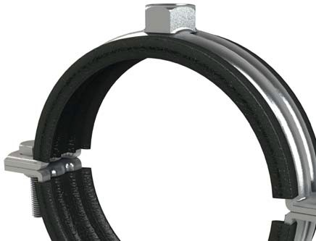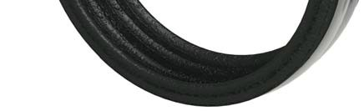

General Description
Heavy duty Rubber Lined Clips are designed for use as an
alternative to standard rubber lined clips where additional load capacity is required. They also make a very good al- ternative to conventioanl heavier duty product such as split bands and bossed split bands.

Manufactured form mild steel with BZP Finish and EPDM Rubber liner, these clips have been tested for dead weight loads and shear loads to ensure their suitability.

Material Specification
Clip: Mild Steel BZP
Screws: High Tensile 8.8 Steel BZP Rubber Liner: EPDM

Additional Information
Can be used with LF2 & LF3 Slide Guides to make Heavy Duty Slide Guides to cater for thermal expansion.

BOSSTM
HEAVY DUTY BZP RUBBER LINED CLIPS

Data Sheet

BSS Code | SIZE | RANGE  (фD) (mm) | STEEL SIZE(WxT) | SCREW SIZE | BOSS SIZE | SHEAR SWL | STATIC SWL
19301301 | 2” | 60-69 | 25x2 | M8x25 | M12 | 4.5kN | 2.75kN
19301312 | 70mm | 67-75 | 25x2 | M8x25 | M12 | 4.5kN | 2.75kN
19301334 | 85mm | 83-91 | 25x2 | M8x25 | M12 | 4.5kN | 2.75kN
19301345 | 3” | 87-95 | 25x2 | M8x25 | M12 | 4.5kN | 2.75kN
19301356 | 100mm | 95-104 | 25x2 | M8x25 | M12 | 4.5kN | 2.75kN
19301367 | 105mm | 102-112 | 30x3 | M10x40 | M12 | 5kN | 3.75kN
19301378 | 4” | 109-119 | 30x3 | M10x40 | M12 | 5kN | 3.75kN
19301389 | 125mm | 122-138 | 30x3 | M10x40 | M12 | 7kN | 6kN
19301419 | 5” | 136-147 | 30x3 | M10x40 | M12 | 7kN | 6kN
19301430 | 160mm | 153-164 | 30x3 | M10x40 | M12 | 7kN | 6kN

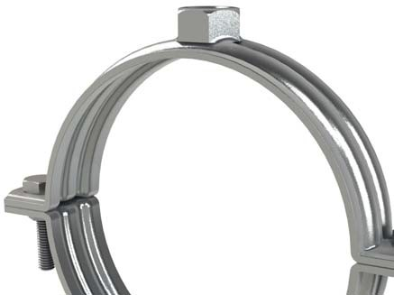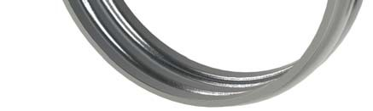

General Description
Heavy duty Rubber Unlined Clips are designed for use as an alternative to standard rubber lined clips where additional load capacity is required. They also make a very good alternative to conventioanl heavier duty product such as split bands and bossed split bands.

Manufactured form mild steel with BZP Finish, these clips have been tested for dead weight loads and shear loads to ensure their suitability.

Material Specification
Clip: Mild Steel BZP
Screws: High Tensile 8.8 Steel BZP Rubber Liner: None

Additional Information
Can be used with LF2 & LF3 Slide Guides to make Heavy Duty Slide Guides to cater for thermal
expansion.

BOSSTM
HEAVY DUTY BZP UNLINED CLIPS

Data Sheet

BSS Code | SIZE | RANGE  (фD) (mm) | STEEL SIZE(WxT) | SCREW SIZE | BOSS SIZE | SHEAR SWL | STATIC SWL
19300974 | 2” | 60-68 | 25x2 | M8x25 | M12 | 4.5kN | 2.75kN
19300985 | 70mm | 66-73 | 25x2 | M8x25 | M12 | 4.5kN | 2.75kN
19300996 | 2 1/2” | 74-81 | 25x2 | M8x25 | M12 | 4.5kN | 2.75kN
19301002 | 80mm | 82-88 | 25x2 | M8x25 | M12 | 4.5kN | 2.75kN
19301013 | 3” | 88-97 | 25x2 | M8x25 | M12 | 4.5kN | 2.75kN
19301024 | 95mm | 93-100 | 25x2 | M8x25 | M12 | 4.5kN | 2.75kN
19301035 | 105mm | 101-109 | 30x3 | M10x40 | M12 | 5kN | 3.75kN
19301046 | 4” | 110-118 | 30x3 | M10x40 | M12 | 5kN | 3.75kN
19301057 | 120mm | 116-126 | 30x3 | M10x40 | M12 | 5kN | 3.75kN
19301068 | 135mm | 130-141 | 30x3 | M10x40 | M12 | 7kN | 6kN
19301079 | 5” | 136-145 | 30x3 | M10x40 | M12 | 7kN | 6kN
19301090 | 150mm | 144-154 | 30x3 | M10x40 | M12 | 7kN | 6kN
19301109 | 6” | 160-169 | 30x3 | M10x40 | M12 | 7kN | 6kN
19301120 | 175mm | 170-180 | 30x3 | M10x40 | M12 | 7kN | 6kN
19301131 | 210mm | 202-214 | 30x3 | M10x40 | M12 | 7kN | 6kN
19301142 | 8” | 219-230 | 30x3 | M10x40 | M12 | 7kN | 6kN
19301153 | 250mm | 245-255 | 30x3 | M10x40 | M12 | 7kN | 6kN
19301164 | 10” | 273-283 | 30x3 | M10x40 | M12 | 7kN | 6kN
19301175 | 12” | 317-333 | 40x4 | M16x40 | M16 | 7kN | 6kN

